Roteiro: Migração do ambiente do MongoDB para AMZ LINUX 2

Criar instância padrão para servir de base para os outros servidores
- Criar Instância
Usei o roteiro do EEC: https://pages.experian.com/display/SC/How+to+build+EC2+instances+using+the+Experian+Golden+AMIs
TAGs:
Key | Value
Bu | Digital
CWRetentionDays | 30
Name | Usar um friendly name (MONGODB-DIGITAL-NOMEDOSISTEMA-X)
ResourceBusinessUnit | Brazil Digital Paas
ResourceAppRole | Db
Description | Instancia padrão para criação de bancos MONGO com imagem Amazon Linux 2
CWAgentInstall | True
Backup | False
ResourceCostCenter | 1800.BR.134.502527
ResourceName | brasa1udbues0.br.experian.eeca1
Key | Value
ResourceOwner | devsecopsdigitalpaas@br.experian.com
Ambiente | UAT
adDomain Ver como está na documentação br.experian.local
Instância criada: i-027c66afe2633cd6c
Nessa instância foram adicionados os seguintes discos:
- Root -> 50GB
- Dados -> 100 GB
- SWAP -> 10 GB
- Procedimentos iniciais:
  - Conectar na instância
  - Atualizar o S.O.:
yum update -y
  - Avaliar a necessidade de atualizar o Kernel: https://aws.amazon.com/pt/premiumsupport/knowledge-center/amazon-linux-2-kernel-upgrade/
- Instalação do MONGO (conforme procedimento: https://www.mongodb.com/docs/v4.4/tutorial/install-mongodb-on-amazon/)
  - Criar o arquivo /etc/yum.repos.d/mongodb-enterprise-4.4.repo, com o seguinte conteúdo:
[mongodb-enterprise-4.4]
name=MongoDB Enterprise Repository
baseurl=https://repo.mongodb.com/yum/amazon/2/mongodb-enterprise/4.4/$basearch/
gpgcheck=1
enabled=1
gpgkey=https://www.mongodb.org/static/pgp/server-4.4.asc
  - Alterar a permissão do arquivo:
chmod 644 /etc/yum.repos.d/mongodb-enterprise-4.4.repo
  - Instalar o mongo:
sudo yum install -y mongodb-enterprise-4.4.19 mongodb-enterprise-server-4.4.19 mongodb-enterprise-shell-4.4.19 mongodb-enterprise-mongos-4.4.19 mongodb-enterprise-tools-4.4.19

  - Para evitar atualizações não intencionais, fixe o pacote. Para fixar um pacote, adicione a diretiva ao arquivo /etc/yum.conf:
exclude=mongodb-enterprise,mongodb-enterprise-server,mongodb-enterprise-shell,mongodb-enterprise-mongos,mongodb-enterprise-tools
  - Na instalação do MONGO são usadas as seguintes pastas:
    - data files in /var/lib/mongo
    - log files in /var/log/mongodb
- Criar disco de dados
  - Criar o file system: mkfs -t xfs /dev/nvme1n1
  - Verificar se o file system está ok: lsblk -f
  - Copiar o UUID do disco para editar o fstab
  - Editar o /etc/fstab:
UUID=5016d139-9f82-4568-a939-d396e6a3ba70 /var/lib/mongo xfs defaults 0 0
  - Executar o mount -a para carregar as alterações do fstab
  - O comand mount para verificar as partições
- Criar disco de SWAP:
  - Criar o disco de SWAP: mkswap /dev/nvme2n1
  - Copiar o UUID do disco para editar o fstab
  - Editar o /etc/fstab:
UUID=8098baa2-19f0-407e-8224-2a87559efd92 swap swap defaults 0 0
  - Ativar o swap: swapon -a
  - O comando swapon verifica estado do swap
- Efetuar boot da instância

Criar servidores a partir da instância criada

- Criar imagem a partir do template criado
aws ec2 create-image --instance-id i-027c66afe2633cd6c --name "ami-mongo-amzlinux2" --description "Imagem para criacao dos servidores MongoDB com Amazon Linux 2" --no-verify-ssl

Imagem criada: ami-023738d6bfc5992cf
- Criar servidores a partir da imagem criada:
  - Criar instância UAT para a subnet A (mongodb-digital-UAT-a)

aws ec2 run-instances --image-id ami-023738d6bfc5992cf --instance-type t3a.large --subnet-id subnet-f940de9e --security-group-ids sg-099e951dfd89a941d sg-0a3bf42cfca7de464 sg-08f75cbb997e39e5d sg-0a183ebfb0b5f1d55 --key-name digital --tag-specifications 'ResourceType=instance,Tags=[{Key=bu,Value=\"digital\"},{Key=CWRetentionDays,Value=\"30\"},{Key=Name,Value=\"BRASA1UDBUES01\"},{Key=ResourceBusinessUnit,Value=\"Brazil_Digital_Paas\"},{Key=ResourceAppRole,Value=\"db\"},{Key=Description,Value=\"Banco_MONGO_UAT_A\"},{Key=CWAgentInstall,Value=\"true\"},{Key=Backup,Value=\"true\"},{Key=ResourceCostCenter,Value=\"1800.BR.134.502527\"},{Key=ResourceName,Value=\"brasa1udbues01.br.experian.eeca\"},{Key=ResourceOwner,Value=\"devsecopsdigitalpaas@br.experian.com\"},{Key=Ambiente,Value=\"UAT\"}]' --no-verify-ssl

Instância criada: i-09b6093c620fdd088

aws ec2 associate-iam-instance-profile --instance-id i-09b6093c620fdd088 --iam-instance-profile Arn=arn:aws:iam::492208500822:instance-profile/eec-aws-amifactory-sc-iam-ec2role --no-verify-ssl

  - Criar instância UAT para a subnet C (mongodb-digital-UAT-c)

aws ec2 run-instances --image-id ami-023738d6bfc5992cf --instance-type t3a.large --subnet-id subnet-e8bdcab0 --security-group-ids sg-099e951dfd89a941d sg-0a3bf42cfca7de464 sg-08f75cbb997e39e5d sg-0a183ebfb0b5f1d55 --key-name digital --tag-specifications 'ResourceType=instance,Tags=[{Key=bu,Value=\"digital\"},{Key=CWRetentionDays,Value=\"30\"},{Key=Name,Value=\"BRASA1UDBUES02\"},{Key=ResourceBusinessUnit,Value=\"Brazil_Digital_Paas\"},{Key=ResourceAppRole,Value=\"db\"},{Key=Description,Value=\"Banco_MONGO_UAT_C\"},{Key=CWAgentInstall,Value=\"true\"},{Key=Backup,Value=\"true\"},{Key=ResourceCostCenter,Value=\"1800.BR.134.502527\"},{Key=ResourceName,Value=\"brasa1udbues02.br.experian.eeca\"},{Key=ResourceOwner,Value=\"devsecopsdigitalpaas@br.experian.com\"},{Key=Ambiente,Value=\"UAT\"}]' --no-verify-ssl

Instância criada: i-06ae7dedaf243db48

aws ec2 associate-iam-instance-profile --instance-id i-06ae7dedaf243db48 --iam-instance-profile Arn=arn:aws:iam::492208500822:instance-profile/eec-aws-amifactory-sc-iam-ec2role --no-verify-ssl

  - Criar instância hidden UAT para a subnet C (mongodb-digital-UAT-hidden)

aws ec2 run-instances --image-id ami-023738d6bfc5992cf --instance-type t3a.large --subnet-id subnet-e8bdcab0 --security-group-ids sg-099e951dfd89a941d sg-0a3bf42cfca7de464 sg-08f75cbb997e39e5d sg-0a183ebfb0b5f1d55 --key-name digital --tag-specifications 'ResourceType=instance,Tags=[{Key=bu,Value=\"digital\"},{Key=CWRetentionDays,Value=\"30\"},{Key=Name,Value=\"BRASA1UDBUES03\"},{Key=ResourceBusinessUnit,Value=\"Brazil_Digital_Paas\"},{Key=ResourceAppRole,Value=\"db\"},{Key=Description,Value=\"Banco_MONGO_UAT_HIDDEN\"},{Key=CWAgentInstall,Value=\"true\"},{Key=Backup,Value=\"true\"},{Key=ResourceCostCenter,Value=\"1800.BR.134.502527\"},{Key=ResourceName,Value=\"brasa1udbues03.br.experian.eeca\"},{Key=ResourceOwner,Value=\"devsecopsdigitalpaas@br.experian.com\"},{Key=Ambiente,Value=\"UAT\"}]' --no-verify-ssl

Instância criada: i-0babd0f1f057910be

aws ec2 associate-iam-instance-profile --instance-id i-0babd0f1f057910be --iam-instance-profile Arn=arn:aws:iam::492208500822:instance-profile/eec-aws-amifactory-sc-iam-ec2role --no-verify-ssl
- Dados dos servidores:
Banco_MONGO_UAT_A - i-09b6093c620fdd088 - 10.97.55.40
Banco_MONGO_UAT_C - i-06ae7dedaf243db48 - 10.97.55.222
Banco_MONGO_UAT_HIDDEN - i-0babd0f1f057910be - 10.97.55.161

Configurar o REPLICASET para adicionar os nós novos no cluster
- Copiar chaves do cluster do MONGO existente para os novos servidores
As chaves são armazenadas na pasta /etc/mongodb/ssl/
[root@brasa1udbues01 ~]# ll /etc/mongodb/ssl
total 8
-r-------- 1 mongod mongod 1004 Oct 3 18:43 clusterdigital-UAT.key
-rw-r----- 1 mongod mongod 2908 Oct 3 18:43 mongodb.pem

- Subir o banco nos novos servidores
systemctl start mongod
systemctl status mongod
- Conectar no master do cluster
Servidor mongodb-digital-UAT-a (instância i-0910811d76707cb87) - 10.97.55.26
mongo -u root -p Root#0018DB -authenticationDatabase admin
- Reconfigurar o cluster:
mongodb-digital-UAT:PRIMARY> cfg = rs.conf()
{
"_id" : "mongodb-digital-UAT",
"version" : 64817,
"protocolVersion" : NumberLong(1),
"writeConcernMajorityJournalDefault" : true,
"members" : [
{
"_id" : 0,
"host" : "10.97.55.26:27017",
"arbiterOnly" : false,
"buildIndexes" : true,
"hidden" : false,
"priority" : 1,
"tags" : {

},
"slaveDelay" : NumberLong(0),
"votes" : 1
},
{
"_id" : 1,
"host" : "10.97.55.235:27017",
"arbiterOnly" : false,
"buildIndexes" : true,
"hidden" : false,
"priority" : 2,
"tags" : {

},
"slaveDelay" : NumberLong(0),
"votes" : 1
},
{
"_id" : 2,
"host" : "10.97.55.101:27017",
"arbiterOnly" : true,
"buildIndexes" : false,
"hidden" : false,
"priority" : 0,
"tags" : {

},
"slaveDelay" : NumberLong(0),
"votes" : 1
}
],
"settings" : {
"chainingAllowed" : true,
"heartbeatIntervalMillis" : 2000,
"heartbeatTimeoutSecs" : 10,
"electionTimeoutMillis" : 10000,
"catchUpTimeoutMillis" : -1,
"catchUpTakeoverDelayMillis" : 30000,
"getLastErrorModes" : {

},
"getLastErrorDefaults" : {
"w" : 1,
"wtimeout" : 0
},
"replicaSetId" : ObjectId("5cddcbe7d10e398cfe40e8e2")
}
}
mongodb-digital-UAT:PRIMARY> cfg.members[0].priority = 10
10
mongodb-digital-UAT:PRIMARY> cfg.members[1].priority = 9
9
mongodb-digital-UAT:PRIMARY> cfg.members[2].priority = 0
0
mongodb-digital-UAT:PRIMARY> rs.reconfig(cfg)
{
"ok" : 1,
"$clusterTime" : {
"clusterTime" : Timestamp(1665412738, 1),
"signature" : {
"hash" : BinData(0,"QAysNgX8f35reKrBYhN3JwrZ+ig="),
"keyId" : NumberLong("7093286661420744706")
}
},
"operationTime" : Timestamp(1665412738, 1)
}
mongodb-digital-UAT:PRIMARY>
mongodb-digital-UAT:SECONDARY>

- Adicionar novos nós no CLUSTER:
mongodb-digital-UAT:PRIMARY> rs.add( { host: "10.97.55.40:27017", priority: 8 } )
{
"ok" : 1,
"$clusterTime" : {
"clusterTime" : Timestamp(1665412950, 2),
"signature" : {
"hash" : BinData(0,"wJ7/fIsBp4utSJduQOnE0SaXvDg="),
"keyId" : NumberLong("7093286661420744706")
}
},
"operationTime" : Timestamp(1665412950, 2)
}
mongodb-digital-UAT:PRIMARY> rs.add( { host: "10.97.55.222:27017", priority: 7 } )
{
"ok" : 1,
"$clusterTime" : {
"clusterTime" : Timestamp(1665413018, 1),
"signature" : {
"hash" : BinData(0,"gRURlw6bvmFmT7tHysnljNXWEGc="),
"keyId" : NumberLong("7093286661420744706")
}
},
"operationTime" : Timestamp(1665413018, 1)
}
mongodb-digital-UAT:PRIMARY> rs.add( { host: "10.97.55.161:27017", priority: 6 } )
{
"ok" : 1,
"$clusterTime" : {
"clusterTime" : Timestamp(1665413042, 1),
"signature" : {
"hash" : BinData(0,"vkiZYxQm+U9OJPg1Ejqt4AEzSQs="),
"keyId" : NumberLong("7093286661420744706")
}
},
"operationTime" : Timestamp(1665413042, 1)
}

- Verificar o cluster:
rs.status().members.forEach(
function(z){
printjson(z.name);
printjson(z.stateStr);
printjson(z.optimeDate);
}
)

"10.97.55.26:27017"
"PRIMARY"
ISODate("2022-10-10T14:44:02Z")
"10.97.55.235:27017"
"SECONDARY"
ISODate("2022-10-10T14:44:02Z")
"10.97.55.101:27017"
"ARBITER"
undefined
"10.97.55.40:27017"
"STARTUP2"
ISODate("1970-01-01T00:00:00Z")
"10.97.55.222:27017"
"STARTUP2"
ISODate("1970-01-01T00:00:00Z")
"10.97.55.161:27017"
"STARTUP2"
ISODate("1970-01-01T00:00:00Z")

- Remover os servidores legados do cluster:
rs.remove("10.97.55.26:27017")
rs.remove("10.97.55.235:27017")
rs.remove("10.97.55.101:27017")

Cluster: mongodb-digital-services-crypto
- Criar servidores a partir da imagem criada:
  - Criar instância CRYPTO para a subnet A (mongodb-digital-services-crypto-a)

aws ec2 run-instances --image-id ami-023738d6bfc5992cf --instance-type m5a.large --subnet-id subnet-f940de9e --security-group-ids sg-0a3bf42cfca7de464 sg-08f75cbb997e39e5d sg-0c1eeb27cfd639d40 --key-name digital --tag-specifications 'ResourceType=instance,Tags=[{Key=bu,Value=\"digital\"},{Key=CWRetentionDays,Value=\"30\"},{Key=Name,Value=\"BRASA1PDBUES01\"},{Key=ResourceBusinessUnit,Value=\"Brazil_Digital_Paas\"},{Key=ResourceAppRole,Value=\"db\"},{Key=Description,Value=\"mongodb-digital-services-crypto-a\"},{Key=CWAgentInstall,Value=\"true\"},{Key=Backup,Value=\"True\"},{Key=ResourceCostCenter,Value=\"1800.BR.134.502527\"},{Key=ResourceName,Value=\"brasa1pdbues01.br.experian.eeca\"},{Key=ResourceOwner,Value=\"devsecopsdigitalpaas@br.experian.com\"},{Key=Ambiente,Value=\"PROD\"},{Key=CSC_BKP,Value=\"ESS\"},{Key=CSC_MON,Value=\"ESS\"},{Key=CSC_SEG,Value=\"ESS\"},{Key=servers,Value=\"mongo\"},{Key=Rapid7Tag,Value=\"eec-aws-br-pme-digital-prod\"},{Key=prommonit,Value=\"TRUE\"},{Key=adDomain,Value=\"br.experian.local\"}]' --no-verify-ssl

Instância criada: i-0ed323388e714556d

aws ec2 associate-iam-instance-profile --instance-id i-0ed323388e714556d --iam-instance-profile Arn=arn:aws:iam::492208500822:instance-profile/eec-aws-amifactory-sc-iam-ec2role --no-verify-ssl

  - Criar instância CRYPTO para a subnet C (mongodb-digital-services-crypto-c)

aws ec2 run-instances --image-id ami-023738d6bfc5992cf --instance-type m5a.large --subnet-id subnet-e8bdcab0 --security-group-ids sg-0a3bf42cfca7de464 sg-08f75cbb997e39e5d sg-0c1eeb27cfd639d40 --key-name digital --tag-specifications 'ResourceType=instance,Tags=[{Key=bu,Value=\"digital\"},{Key=CWRetentionDays,Value=\"30\"},{Key=Name,Value=\"BRASA1PDBUES02\"},{Key=ResourceBusinessUnit,Value=\"Brazil_Digital_Paas\"},{Key=ResourceAppRole,Value=\"db\"},{Key=Description,Value=\"mongodb-digital-services-crypto-c\"},{Key=CWAgentInstall,Value=\"true\"},{Key=Backup,Value=\"True\"},{Key=ResourceCostCenter,Value=\"1800.BR.134.502527\"},{Key=ResourceName,Value=\"brasa1pdbues02.br.experian.eeca\"},{Key=ResourceOwner,Value=\"devsecopsdigitalpaas@br.experian.com\"},{Key=Ambiente,Value=\"PROD\"},{Key=CSC_BKP,Value=\"ESS\"},{Key=CSC_MON,Value=\"ESS\"},{Key=CSC_SEG,Value=\"ESS\"},{Key=servers,Value=\"mongo\"},{Key=Rapid7Tag,Value=\"eec-aws-br-pme-digital-prod\"},{Key=prommonit,Value=\"TRUE\"},{Key=adDomain,Value=\"br.experian.local\"}]' --no-verify-ssl

Instância criada: i-04af658f242cb1f96

aws ec2 associate-iam-instance-profile --instance-id i-04af658f242cb1f96 --iam-instance-profile Arn=arn:aws:iam::492208500822:instance-profile/eec-aws-amifactory-sc-iam-ec2role --no-verify-ssl

  - Criar instância CRYPTO para Hidden (mongodb-digital-services-crypto-hidden)

aws ec2 run-instances --image-id ami-023738d6bfc5992cf --instance-type m5a.large --subnet-id subnet-e8bdcab0 --security-group-ids sg-0a3bf42cfca7de464 sg-08f75cbb997e39e5d sg-0c1eeb27cfd639d40 --key-name digital --tag-specifications 'ResourceType=instance,Tags=[{Key=bu,Value=\"digital\"},{Key=CWRetentionDays,Value=\"30\"},{Key=Name,Value=\"BRASA1PDBUES03\"},{Key=ResourceBusinessUnit,Value=\"Brazil_Digital_Paas\"},{Key=ResourceAppRole,Value=\"db\"},{Key=Description,Value=\"mongodb-digital-services-crypto-hidden\"},{Key=CWAgentInstall,Value=\"true\"},{Key=Backup,Value=\"True\"},{Key=ResourceCostCenter,Value=\"1800.BR.134.502527\"},{Key=ResourceName,Value=\"brasa1pdbues03.br.experian.eeca\"},{Key=ResourceOwner,Value=\"devsecopsdigitalpaas@br.experian.com\"},{Key=Ambiente,Value=\"PROD\"},{Key=CSC_BKP,Value=\"ESS\"},{Key=CSC_MON,Value=\"ESS\"},{Key=CSC_SEG,Value=\"ESS\"},{Key=servers,Value=\"mongo\"},{Key=Rapid7Tag,Value=\"eec-aws-br-pme-digital-prod\"},{Key=prommonit,Value=\"TRUE\"},{Key=adDomain,Value=\"br.experian.local\"}]' --no-verify-ssl

aws ec2 run-instances --image-id ami-023738d6bfc5992cf --instance-type t3a.large --subnet-id subnet-e8bdcab0 --security-group-ids sg-099e951dfd89a941d sg-0a3bf42cfca7de464 sg-08f75cbb997e39e5d sg-0a183ebfb0b5f1d55 --key-name digital --tag-specifications 'ResourceType=instance,Tags=[{Key=bu,Value=\"digital\"},{Key=CWRetentionDays,Value=\"30\"},{Key=Name,Value=\"BRASA1UDBUES03\"},{Key=ResourceBusinessUnit,Value=\"Brazil_Digital_Paas\"},{Key=ResourceAppRole,Value=\"db\"},{Key=Description,Value=\"Banco_MONGO_UAT_HIDDEN\"},{Key=CWAgentInstall,Value=\"true\"},{Key=Backup,Value=\"true\"},{Key=ResourceCostCenter,Value=\"1800.BR.134.502527\"},{Key=ResourceName,Value=\"brasa1udbues03.br.experian.eeca\"},{Key=ResourceOwner,Value=\"devsecopsdigitalpaas@br.experian.com\"},{Key=Ambiente,Value=\"UAT\"}]' --no-verify-ssl

Instância criada: i-0ccbbc0759f3f921f

aws ec2 associate-iam-instance-profile --instance-id i-0ccbbc0759f3f921f --iam-instance-profile Arn=arn:aws:iam::492208500822:instance-profile/eec-aws-amifactory-sc-iam-ec2role --no-verify-ssl
- Dados dos servidores:
Name | Backup | bu | Ambiente | Description | Instance ID | Instance state | Instance type | Availability Zone | Private IP | Key name
BRASA1PDBUES01 | True | digital | PROD | mongodb-digital-services-crypto-a | i-0ed323388e714556d | Running | m5a.large | sa-east-1a | 10.97.55.126 | digital
BRASA1PDBUES02 | True | digital | PROD | mongodb-digital-services-crypto-c | i-04af658f242cb1f96 | Running | m5a.large | sa-east-1c | 10.97.55.149 | digital
BRASA1PDBUES03 | True | digital | PROD | mongodb-digital-services-crypto-b | i-0ccbbc0759f3f921f | Running | m5a.large | sa-east-1c | 10.97.55.250 | digital

Pós-Instalação:
Configuração do acesso ao Ansible:
#Criar user e definir uma senha para ele
useradd usr_ansible
echo "Anldtel1nd@" | passwd usr_ansible --stdin
# passwd usr_ansible

#Configuração de chave ssh do usuário usr_ansible
su - usr_ansible
mkdir .ssh
chmod 700 .ssh
touch .ssh/authorized_keys
chmod 600 .ssh/authorized_keys
wget http://10.96.170.146/pub/id_rsa_usr_ansible.pub
cat id_rsa_usr_ansible.pub > .ssh/authorized_keys
rm -rf id_rsa_usr_ansible.pub
exit
echo " usr_ansible ALL=(ALL) NOPASSWD: ALL" >> /etc/sudoers.d/usr_ansible

Instalação do Zabbix:
wget https://repo.zabbix.com/zabbix/6.0/rhel/7/x86_64/zabbix-agent2-6.0.0-1.el7.x86_64.rpm

yum localinstall zabbix-agent2-6.0.0-1.el7.x86_64.rpm -y

wget https://file-share-claranet.s3.sa-east-1.amazonaws.com/zabbix_agent2.conf

mv /etc/zabbix/zabbix_agent2.conf /etc/zabbix/zabbix_agent2.conf.old
mv zabbix_agent2.conf /etc/zabbix/zabbix_agent2.conf
chmod 644 /etc/zabbix/zabbix_agent2.conf
ll /etc/zabbix/
systemctl restart zabbix-agent2.service
systemctl status zabbix-agent2.service

- Criar imagem a partir da revisão do template
aws ec2 create-image --instance-id i-027c66afe2633cd6c --name "ami-mongo-amzlinux2-v.2022.10.20" --description "Imagem para criacao dos servidores MongoDB com Amazon Linux 2" --no-verify-ssl

Imagem criada: ami-0db6982326aba4b1b

aws ec2 deregister-image --image-id ami-08965ff5c7e2950da --no-verify-ssl

Conectar no mongo:
mongo -u root -p Root#0018DB -authenticationDatabase admin

Início da Change:
Alterar os servidores novos, desabilitando o modo hidden:
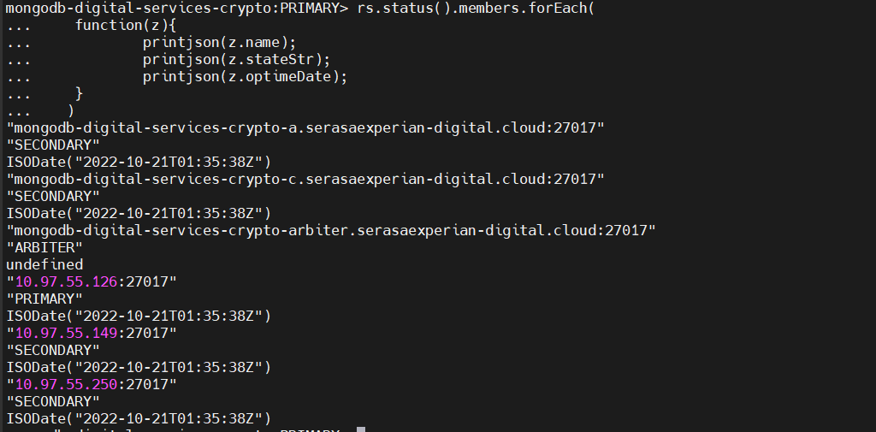

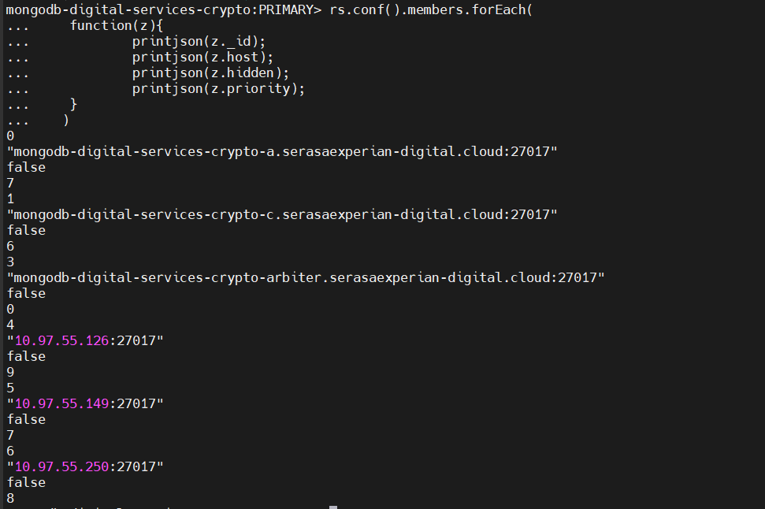

Alterar a string de conexão das aplicações para conectar apenas nos novos bancos:
digital-services-crypto
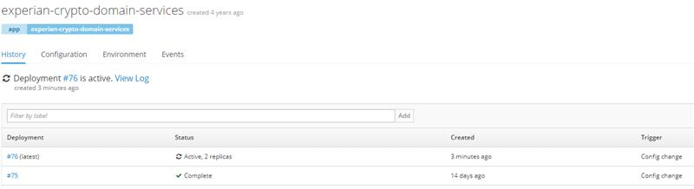
experian-crypto-domain-services
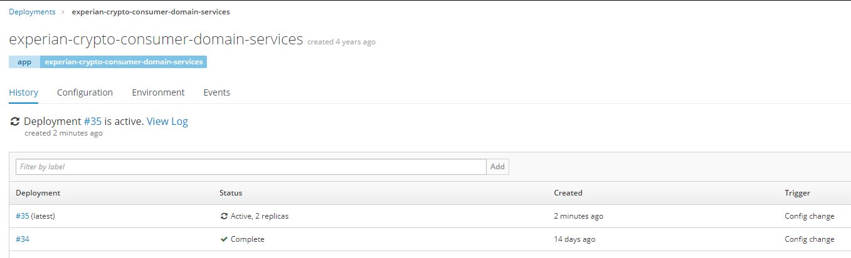
Alertas do Zabbix:
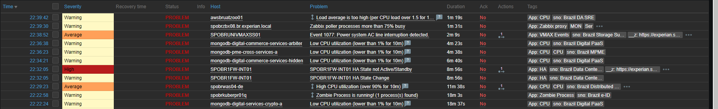
Remover nós antigos do cluster do Mongo:
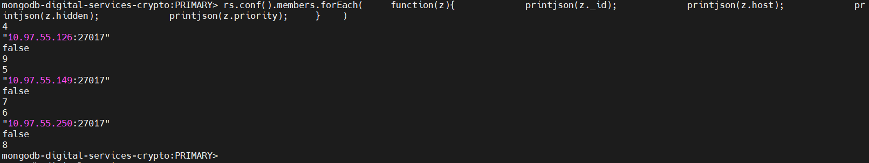
Alertas após remoção dos bancos – previstos:
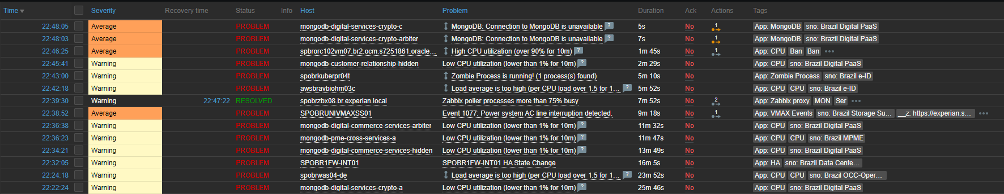

Cluster: mongodb-digital-commerce-services
Servidores legados:
IP | Instance | Name | Subnet | Tipo | VPC
10.97.55.121 | i-05d7db10910489ee1 | mongodb-digital-commerce-services-a | subnet-f940de9e | m5a.xlarge | vpc-a1716ac5
10.97.55.91 | i-06dc80dd0b831d192 | mongodb-digital-commerce-services-arbiter | subnet-f940de9e | t3a.micro | vpc-a1716ac5
10.97.55.132 | i-0fd668af0697758b4 | mongodb-digital-commerce-services-c | subnet-e8bdcab0 | m5a.xlarge | vpc-a1716ac5
10.97.55.183 | i-078c1b7ccdaa49ff8 | mongodb-digital-commerce-services-hidden | subnet-e8bdcab0 | m5a.xlarge | vpc-a1716ac5

Discos:
Volume ID | Device name | Volume size (GiB) | Attachment status | Encrypted | KMS key ID | Delete on termination
vol-0649cf1d47f187a62 | /dev/sds | 10 | Attached | Yes | a8f3d4ad-8dc9-4e42-a965-929588bc2082 | Yes
vol-08e04610c48ea5afd | /dev/sdb | 600 | Attached | Yes | a8f3d4ad-8dc9-4e42-a965-929588bc2082 | Yes
vol-0e1a32325a2845bcd | /dev/sda1 | 50 | Attached | Yes | a8f3d4ad-8dc9-4e42-a965-929588bc2082 | No
- Criar servidores a partir da imagem criada:
  - Criar instância COMMERCE para a subnet A (mongodb-digital-commerce-services-a)

aws ec2 run-instances --image-id ami-0db6982326aba4b1b --instance-type m5a.xlarge --subnet-id subnet-f940de9e --security-group-ids sg-0a3bf42cfca7de464 sg-08f75cbb997e39e5d sg-0c1eeb27cfd639d40 --key-name digital --tag-specifications 'ResourceType=instance,Tags=[{Key=bu,Value=\"digital\"},{Key=CWRetentionDays,Value=\"30\"},{Key=Name,Value=\"BRASA1PDBUES04\"},{Key=ResourceBusinessUnit,Value=\"Brazil_Digital_Paas\"},{Key=ResourceAppRole,Value=\"db\"},{Key=Description,Value=\" mongodb-digital-commerce-services-a(BRASA1PDBUES04)\"},{Key=CWAgentInstall,Value=\"true\"},{Key=Backup,Value=\"True\"},{Key=ResourceCostCenter,Value=\"1800.BR.134.502527\"},{Key=ResourceName,Value=\"brasa1pdbues04.br.experian.eeca\"},{Key=ResourceOwner,Value=\"devsecopsdigitalpaas@br.experian.com\"},{Key=Ambiente,Value=\"PROD\"},{Key=CSC_BKP,Value=\"ESS\"},{Key=CSC_MON,Value=\"ESS\"},{Key=CSC_SEG,Value=\"ESS\"},{Key=servers,Value=\"mongo\"},{Key=Rapid7Tag,Value=\"eec-aws-br-pme-digital-prod\"},{Key=prommonit,Value=\"TRUE\"},{Key=adDomain,Value=\"br.experian.local\"}]' --no-verify-ssl

Instância criada: i-0800ad2c3e53e525f

Listar volumes da instância:
aws ec2 describe-instances --instance-id InstanceID --query 'Reservations[].Instances[].BlockDeviceMappings[].[DeviceName,Ebs.VolumeId]' --output text --no-verify-ssl
ou
aws ec2 describe-volumes --query "Volumes[*].[Attachments[0].Device,VolumeId,Size,VolumeType]" --output text --no-verify-ssl --filters Name=attachment.instance-id,Values=i-0800ad2c3e53e525f
/dev/xvda vol-0c48093be96d8c77c 50 gp2
/dev/sdb vol-0885c2de2028dc7a8 100 gp3
/dev/sdf vol-00d503095b2e2f790 10 gp3

aws ec2 modify-volume --size 600 --volume-id vol-0885c2de2028dc7a8 --no-verify-ssl

aws ec2 associate-iam-instance-profile --instance-id i-0800ad2c3e53e525f --iam-instance-profile Arn=arn:aws:iam::492208500822:instance-profile/eec-aws-amifactory-sc-iam-ec2role --no-verify-ssl

conectar na instância via ssh e executar os comandos:

xfs_growfs -d /var/lib/mongo

systemctl restart zabbix-agent2.service
systemctl status zabbix-agent2.service

- Criar instância COMMERCE para a subnet C (mongodb-digital-commerce-services-c)

aws ec2 run-instances --image-id ami-0db6982326aba4b1b --instance-type m5a.xlarge --subnet-id subnet-f940de9e --security-group-ids sg-0a3bf42cfca7de464 sg-08f75cbb997e39e5d sg-0c1eeb27cfd639d40 --key-name digital --tag-specifications 'ResourceType=instance,Tags=[{Key=bu,Value=\"digital\"},{Key=CWRetentionDays,Value=\"30\"},{Key=Name,Value=\"BRASA1PDBUES05\"},{Key=ResourceBusinessUnit,Value=\"Brazil_Digital_Paas\"},{Key=ResourceAppRole,Value=\"db\"},{Key=Description,Value=\"mongodb-digital-commerce-services-c(BRASA1PDBUES05)\"},{Key=CWAgentInstall,Value=\"true\"},{Key=Backup,Value=\"True\"},{Key=ResourceCostCenter,Value=\"1800.BR.134.502527\"},{Key=ResourceName,Value=\"brasa1pdbues05.br.experian.eeca\"},{Key=ResourceOwner,Value=\"devsecopsdigitalpaas@br.experian.com\"},{Key=Ambiente,Value=\"PROD\"},{Key=CSC_BKP,Value=\"ESS\"},{Key=CSC_MON,Value=\"ESS\"},{Key=CSC_SEG,Value=\"ESS\"},{Key=servers,Value=\"mongo\"},{Key=Rapid7Tag,Value=\"eec-aws-br-pme-digital-prod\"},{Key=prommonit,Value=\"TRUE\"},{Key=adDomain,Value=\"br.experian.local\"}]' --no-verify-ssl

Instância criada: i-099fa3f8699c87888

Listar volumes da instância:
aws ec2 describe-instances --instance-id InstanceID --query 'Reservations[].Instances[].BlockDeviceMappings[].[DeviceName,Ebs.VolumeId]' --output text --no-verify-ssl
ou
aws ec2 describe-volumes --query "Volumes[*].[Attachments[0].Device,VolumeId,Size,VolumeType]" --output text --no-verify-ssl --filters Name=attachment.instance-id,Values=i-099fa3f8699c87888
/dev/xvda vol-0785930df1778d430 50 gp2
/dev/sdb vol-0ad551172f1696371 100 gp3
/dev/sdf vol-084279577e8c39aea 10 gp3

aws ec2 modify-volume --size 600 --volume-id vol-0ad551172f1696371 --no-verify-ssl

aws ec2 associate-iam-instance-profile --instance-id i-099fa3f8699c87888 --iam-instance-profile Arn=arn:aws:iam::492208500822:instance-profile/eec-aws-amifactory-sc-iam-ec2role --no-verify-ssl

conectar na instância via ssh e executar os comandos:

xfs_growfs -d /var/lib/mongo

systemctl restart zabbix-agent2.service
systemctl status zabbix-agent2.service

- Criar terceira instância COMMERCE para a subnet C (mongodb-digital-commerce-services-b)

aws ec2 run-instances --image-id ami-0db6982326aba4b1b --instance-type m5a.xlarge --subnet-id subnet-f940de9e --security-group-ids sg-0a3bf42cfca7de464 sg-08f75cbb997e39e5d sg-0c1eeb27cfd639d40 --key-name digital --tag-specifications 'ResourceType=instance,Tags=[{Key=bu,Value=\"digital\"},{Key=CWRetentionDays,Value=\"30\"},{Key=Name,Value=\"BRASA1PDBUES06\"},{Key=ResourceBusinessUnit,Value=\"Brazil_Digital_Paas\"},{Key=ResourceAppRole,Value=\"db\"},{Key=Description,Value=\"mongodb-digital-commerce-services-b(BRASA1PDBUES06)\"},{Key=CWAgentInstall,Value=\"true\"},{Key=Backup,Value=\"True\"},{Key=ResourceCostCenter,Value=\"1800.BR.134.502527\"},{Key=ResourceName,Value=\"brasa1pdbues06.br.experian.eeca\"},{Key=ResourceOwner,Value=\"devsecopsdigitalpaas@br.experian.com\"},{Key=Ambiente,Value=\"PROD\"},{Key=CSC_BKP,Value=\"ESS\"},{Key=CSC_MON,Value=\"ESS\"},{Key=CSC_SEG,Value=\"ESS\"},{Key=servers,Value=\"mongo\"},{Key=Rapid7Tag,Value=\"eec-aws-br-pme-digital-prod\"},{Key=prommonit,Value=\"TRUE\"},{Key=adDomain,Value=\"br.experian.local\"}]' --no-verify-ssl

Instância criada: i-06ceda17246264eb3

Listar volumes da instância:
aws ec2 describe-instances --instance-id InstanceID --query 'Reservations[].Instances[].BlockDeviceMappings[].[DeviceName,Ebs.VolumeId]' --output text --no-verify-ssl
ou
aws ec2 describe-volumes --query "Volumes[*].[Attachments[0].Device,VolumeId,Size,VolumeType]" --output text --no-verify-ssl --filters Name=attachment.instance-id,Values= i-06ceda17246264eb3
/dev/sdb vol-04d99fcf2495eadcf 100 gp3
/dev/sdf vol-05057279707ca7cca 10 gp3
/dev/xvda vol-07de6d7d27d7c0030 50 gp2

aws ec2 modify-volume --size 600 --volume-id vol-04d99fcf2495eadcf --no-verify-ssl

aws ec2 associate-iam-instance-profile --instance-id i-06ceda17246264eb3 --iam-instance-profile Arn=arn:aws:iam::492208500822:instance-profile/eec-aws-amifactory-sc-iam-ec2role --no-verify-ssl

conectar na instância via ssh e executar os comandos:

xfs_growfs -d /var/lib/mongo

systemctl restart zabbix-agent2.service
systemctl status zabbix-agent2.service

- Dados dos servidores:
Name | Description | Instance ID | Instance type | Availability Zone | IP | Key name
BRASA1PDBUES04 | mongodb-digital-commerce-services-a(BRASA1PDBUES04) | i-0800ad2c3e53e525f | m5a.xlarge | sa-east-1a | 10.97.55.105 | digital
BRASA1PDBUES05 | mongodb-digital-commerce-services-c(BRASA1PDBUES05) | i-099fa3f8699c87888 | m5a.xlarge | sa-east-1a | 10.97.55.89 | digital
BRASA1PDBUES06 | mongodb-digital-commerce-services-b(BRASA1PDBUES06) | i-06ceda17246264eb3 | m5a.xlarge | sa-east-1a | 10.97.55.70 | digital

Cluster: mongodb-persona-video-loan
Servidores legados:
IP | Instance | Name | Subnet | Tipo | Chave | VPC
10.97.55.102 | i-0809ebaa1aa9a4540 | mongodb-persona-video-loan-a | subnet-f940de9e | m5a.2xlarge | claranet-keypair | vpc-a1716ac5
10.97.55.28 | i-0d56a7694bbc0bf5c | mongodb-persona-video-loan-arbiter | subnet-f940de9e | t3a.micro | claranet-keypair | vpc-a1716ac5
10.97.55.166 | i-02569e3dc6cca35ad | mongodb-persona-video-loan-c | subnet-e8bdcab0 | m5a.2xlarge | claranet-keypair | vpc-a1716ac5

Discos:
Volume ID | Device name | Volume size (GiB) | Encrypted | KMS key ID | Delete on termination
vol-02d88e0a811ef6582 | /dev/sda1 | 80 | Yes | a8f3d4ad-8dc9-4e42-a965-929588bc2082 | Yes
vol-09a8347079ab31a3b | /dev/sdb | 500 | Yes | a8f3d4ad-8dc9-4e42-a965-929588bc2082 | Yes
vol-0e9e45dffd97cbfe5 | /dev/sds | 10 | Yes | a8f3d4ad-8dc9-4e42-a965-929588bc2082 | Yes

- Criar servidores a partir da imagem criada:
  - Criar instância VIDEO-LOAN para a subnet A (mongodb-persona-video-loan-a)

aws ec2 run-instances --image-id ami-0db6982326aba4b1b --instance-type m5a.2xlarge --subnet-id subnet-f940de9e --security-group-ids sg-00d6d62a88c2f01d7 sg-08f75cbb997e39e5d sg-0a3bf42cfca7de464 --key-name digital --tag-specifications 'ResourceType=instance,Tags=[{Key=bu,Value=\"digital\"},{Key=CWRetentionDays,Value=\"30\"},{Key=Name,Value=\"BRASA1PDBUES07\"},{Key=ResourceBusinessUnit,Value=\"Brazil_Digital_Paas\"},{Key=ResourceAppRole,Value=\"db\"},{Key=Description,Value=\"mongodb-persona-video-loan-a(BRASA1PDBUES07)\"},{Key=CWAgentInstall,Value=\"true\"},{Key=Backup,Value=\"True\"},{Key=ResourceCostCenter,Value=\"1800.BR.134.502527\"},{Key=ResourceName,Value=\"brasa1pdbues07.br.experian.eeca\"},{Key=ResourceOwner,Value=\"devsecopsdigitalpaas@br.experian.com\"},{Key=Ambiente,Value=\"PROD\"},{Key=CSC_BKP,Value=\"ESS\"},{Key=CSC_MON,Value=\"ESS\"},{Key=CSC_SEG,Value=\"ESS\"},{Key=servers,Value=\"mongo\"},{Key=Rapid7Tag,Value=\"eec-aws-br-pme-digital-prod\"},{Key=prommonit,Value=\"TRUE\"},{Key=adDomain,Value=\"br.experian.local\"}]' --no-verify-ssl

Instância criada: i-0d25ec248c7203a51

Listar volumes da instância:
aws ec2 describe-instances --instance-id InstanceID --query 'Reservations[].Instances[].BlockDeviceMappings[].[DeviceName,Ebs.VolumeId]' --output text --no-verify-ssl
ou
aws ec2 describe-volumes --query "Volumes[*].[Attachments[0].Device,VolumeId,Size,VolumeType]" --output text --no-verify-ssl --filters Name=attachment.instance-id,Values= i-0d25ec248c7203a51
/dev/sdf vol-078025c0021c52012 10 gp3
/dev/sdb vol-04ffaf7079af53a0f 100 gp3
/dev/xvda vol-012b0cf32f3bbe543 50 gp2

aws ec2 modify-volume --size 600 --volume-id vol-04ffaf7079af53a0f --no-verify-ssl

aws ec2 associate-iam-instance-profile --instance-id i-0d25ec248c7203a51 --iam-instance-profile Arn=arn:aws:iam::492208500822:instance-profile/eec-aws-amifactory-sc-iam-ec2role --no-verify-ssl

conectar na instância via ssh e executar os comandos:

xfs_growfs -d /var/lib/mongo

systemctl restart zabbix-agent2.service
systemctl status zabbix-agent2.service

  - Criar instância VIDEO-LOAN para a subnet C (mongodb-persona-video-loan-a)

aws ec2 run-instances --image-id ami-0db6982326aba4b1b --instance-type m5a.2xlarge --subnet-id subnet-f940de9e --security-group-ids sg-00d6d62a88c2f01d7 sg-08f75cbb997e39e5d sg-0a3bf42cfca7de464 --key-name digital --tag-specifications 'ResourceType=instance,Tags=[{Key=bu,Value=\"digital\"},{Key=CWRetentionDays,Value=\"30\"},{Key=Name,Value=\"BRASA1PDBUES08\"},{Key=ResourceBusinessUnit,Value=\"Brazil_Digital_Paas\"},{Key=ResourceAppRole,Value=\"db\"},{Key=Description,Value=\"mongodb-persona-video-loan-c(BRASA1PDBUES08)\"},{Key=CWAgentInstall,Value=\"true\"},{Key=Backup,Value=\"True\"},{Key=ResourceCostCenter,Value=\"1800.BR.134.502527\"},{Key=ResourceName,Value=\"brasa1pdbues08.br.experian.eeca\"},{Key=ResourceOwner,Value=\"devsecopsdigitalpaas@br.experian.com\"},{Key=Ambiente,Value=\"PROD\"},{Key=CSC_BKP,Value=\"ESS\"},{Key=CSC_MON,Value=\"ESS\"},{Key=CSC_SEG,Value=\"ESS\"},{Key=servers,Value=\"mongo\"},{Key=Rapid7Tag,Value=\"eec-aws-br-pme-digital-prod\"},{Key=prommonit,Value=\"TRUE\"},{Key=adDomain,Value=\"br.experian.local\"}]' --no-verify-ssl

Instância criada: i-0d63824d732241b3b

Listar volumes da instância:
aws ec2 describe-instances --instance-id InstanceID --query 'Reservations[].Instances[].BlockDeviceMappings[].[DeviceName,Ebs.VolumeId]' --output text --no-verify-ssl
ou
aws ec2 describe-volumes --query "Volumes[*].[Attachments[0].Device,VolumeId,Size,VolumeType]" --output text --no-verify-ssl --filters Name=attachment.instance-id,Values=i-0d63824d732241b3b
/dev/sdf vol-0bc67d2f86a68935d 10 gp3
/dev/sdb vol-0f413e6bd880066c7 100 gp3
/dev/xvda vol-008de2344fd0009c3 50 gp2

aws ec2 modify-volume --size 600 --volume-id vol-0f413e6bd880066c7 --no-verify-ssl

aws ec2 associate-iam-instance-profile --instance-id i-0d63824d732241b3b --iam-instance-profile Arn=arn:aws:iam::492208500822:instance-profile/eec-aws-amifactory-sc-iam-ec2role --no-verify-ssl

conectar na instância via ssh e executar os comandos:

xfs_growfs -d /var/lib/mongo

systemctl restart zabbix-agent2.service
systemctl status zabbix-agent2.service

  - Criar terceira instância VIDEO-LOAN para a subnet C (mongodb-persona-video-loan-b)

aws ec2 run-instances --image-id ami-0db6982326aba4b1b --instance-type m5a.2xlarge --subnet-id subnet-f940de9e --security-group-ids sg-00d6d62a88c2f01d7 sg-08f75cbb997e39e5d sg-0a3bf42cfca7de464 --key-name digital --tag-specifications 'ResourceType=instance,Tags=[{Key=bu,Value=\"digital\"},{Key=CWRetentionDays,Value=\"30\"},{Key=Name,Value=\"BRASA1PDBUES09\"},{Key=ResourceBusinessUnit,Value=\"Brazil_Digital_Paas\"},{Key=ResourceAppRole,Value=\"db\"},{Key=Description,Value=\"mongodb-persona-video-loan-b(BRASA1PDBUES09)\"},{Key=CWAgentInstall,Value=\"true\"},{Key=Backup,Value=\"True\"},{Key=ResourceCostCenter,Value=\"1800.BR.134.502527\"},{Key=ResourceName,Value=\"brasa1pdbues09.br.experian.eeca\"},{Key=ResourceOwner,Value=\"devsecopsdigitalpaas@br.experian.com\"},{Key=Ambiente,Value=\"PROD\"},{Key=CSC_BKP,Value=\"ESS\"},{Key=CSC_MON,Value=\"ESS\"},{Key=CSC_SEG,Value=\"ESS\"},{Key=servers,Value=\"mongo\"},{Key=Rapid7Tag,Value=\"eec-aws-br-pme-digital-prod\"},{Key=prommonit,Value=\"TRUE\"},{Key=adDomain,Value=\"br.experian.local\"}]' --no-verify-ssl

Instância criada: i-0d63824d732241b3b

Listar volumes da instância:
aws ec2 describe-instances --instance-id InstanceID --query 'Reservations[].Instances[].BlockDeviceMappings[].[DeviceName,Ebs.VolumeId]' --output text --no-verify-ssl
ou
aws ec2 describe-volumes --query "Volumes[*].[Attachments[0].Device,VolumeId,Size,VolumeType]" --output text --no-verify-ssl --filters Name=attachment.instance-id,Values=i-0f56b7e4cc184452f
/dev/xvda vol-0149a7c32daa56416 50 gp2
/dev/sdb vol-0852ce5cc3490fc77 100 gp3
/dev/sdf vol-072cc69d4390ef3d3 10 gp3

aws ec2 modify-volume --size 600 --volume-id vol-0852ce5cc3490fc77 --no-verify-ssl

aws ec2 associate-iam-instance-profile --instance-id i-0f56b7e4cc184452f --iam-instance-profile Arn=arn:aws:iam::492208500822:instance-profile/eec-aws-amifactory-sc-iam-ec2role --no-verify-ssl

conectar na instância via ssh e executar os comandos:

xfs_growfs -d /var/lib/mongo

systemctl restart zabbix-agent2.service
systemctl status zabbix-agent2.service

- Dados dos servidores:
Name | Description | Instance ID | Instance type | Availability Zone |  | Key name
BRASA1PDBUES07 | mongodb-persona-video-loan-a(BRASA1PDBUES07) | i-0d25ec248c7203a51 | m5a.2xlarge | sa-east-1a | 10.97.55.81 | digital
BRASA1PDBUES09 | mongodb-persona-video-loan-b(BRASA1PDBUES09) | i-0f56b7e4cc184452f | m5a.2xlarge | sa-east-1a | 10.97.55.14 | digital
BRASA1PDBUES08 | mongodb-persona-video-loan-c(BRASA1PDBUES08) | i-0d63824d732241b3b | m5a.2xlarge | sa-east-1a | 10.97.55.104 | digital

Cluster: mongodb-cadpositivo-dispute
Servidores legados:
Name | Chave | IP | Instance | Subnet | Tipo
mongodb-cadpositivo-dispute-a | claranet-keypair-mongodb | 10.97.55.21 | i-04b620db71f3cf789 | subnet-f940de9e | m5a.xlarge
mongodb-cadpositivo-dispute-arbiter | claranet-keypair-mongodb | 10.97.55.111 | i-050ca62340d919760 | subnet-f940de9e | t3a.micro
mongodb-cadpositivo-dispute-c | claranet-keypair-mongodb | 10.97.55.212 | i-0c9c159fdfaedc089 | subnet-e8bdcab0 | m5a.xlarge
mongodb-cadpositivo-dispute-hidden | claranet-keypair-mongodb | 10.97.55.156 | i-068ae1dcb7e9187c2 | subnet-e8bdcab0 | m5a.xlarge

Discos:
Volume ID | Device name | Volume size (GiB) | Encrypted | KMS key ID | Delete on termination
vol-06cd216cc6b174dd2 | /dev/sda1 | 30 | Yes | a8f3d4ad-8dc9-4e42-a965-929588bc2082 | Yes
vol-0b6873b8ceeffc2cd | /dev/sdd | 7500 | Yes | a8f3d4ad-8dc9-4e42-a965-929588bc2082 | Yes
vol-09a149673ba7fccee | /dev/sdk | 10 | Yes | a8f3d4ad-8dc9-4e42-a965-929588bc2082 | Yes
- Criar servidores a partir da imagem criada:
  - Criar instância CADPOSITIVO-DISPUTE para a subnet A (mongodb-cadpositivo-dispute-a)

aws ec2 run-instances --image-id ami-0db6982326aba4b1b --instance-type m5a.xlarge --subnet-id subnet-f940de9e --security-group-ids sg-00d6d62a88c2f01d7 sg-08f75cbb997e39e5d sg-0a3bf42cfca7de464 sg-0c1eeb27cfd639d40 --key-name digital --tag-specifications 'ResourceType=instance,Tags=[{Key=bu,Value=\"ecs\"},{Key=CWRetentionDays,Value=\"30\"},{Key=Name,Value=\"BRASA1PDBUES10\"},{Key=ResourceBusinessUnit,Value=\"Brazil_Digital_Paas\"},{Key=ResourceAppRole,Value=\"db\"},{Key=Description,Value=\"mongodb-cadpositivo-dispute-a(BRASA1PDBUES10)\"},{Key=CWAgentInstall,Value=\"true\"},{Key=Backup,Value=\"True\"},{Key=ResourceCostCenter,Value=\"1800.BR.134.502527\"},{Key=ResourceName,Value=\"brasa1pdbues10.br.experian.eeca\"},{Key=ResourceOwner,Value=\"devsecopsdigitalpaas@br.experian.com\"},{Key=Ambiente,Value=\"PROD\"},{Key=CSC_BKP,Value=\"ESS\"},{Key=CSC_MON,Value=\"ESS\"},{Key=CSC_SEG,Value=\"ESS\"},{Key=servers,Value=\"mongo\"},{Key=Rapid7Tag,Value=\"eec-aws-br-pme-digital-prod\"},{Key=prommonit,Value=\"TRUE\"},{Key=adDomain,Value=\"br.experian.local\"}]' --no-verify-ssl

Instância criada: i-0d41d451632d5385f (10.97.55.64)

Listar volumes da instância:
aws ec2 describe-volumes --query "Volumes[*].[Attachments[0].Device,VolumeId,Size,VolumeType]" --output text --no-verify-ssl --filters Name=attachment.instance-id,Values=i-0d41d451632d5385f
/dev/sdf vol-04e8e4b80814a3eeb 10 gp3
/dev/sdb vol-019f7b6c8c030fad1 100 gp3
/dev/xvda vol-09fbd5ab747418605 50 gp2

aws ec2 modify-volume --size 8500 --volume-id vol-019f7b6c8c030fad1 --no-verify-ssl

aws ec2 associate-iam-instance-profile --instance-id i-0d41d451632d5385f --iam-instance-profile Arn=arn:aws:iam::492208500822:instance-profile/BURoleForDigitalEC2-SSM --no-verify-ssl

conectar na instância via ssh e executar os comandos:

xfs_growfs -d /var/lib/mongo

systemctl restart zabbix-agent2.service
systemctl status zabbix-agent2.service

- Criar instância CADPOSITIVO-DISPUTE para a subnet C (mongodb-cadpositivo-dispute-c)

aws ec2 run-instances --image-id ami-0db6982326aba4b1b --instance-type m5a.xlarge --subnet-id subnet-e8bdcab0 --security-group-ids sg-00d6d62a88c2f01d7 sg-08f75cbb997e39e5d sg-0a3bf42cfca7de464 --key-name digital --tag-specifications 'ResourceType=instance,Tags=[{Key=bu,Value=\"ecs\"},{Key=CWRetentionDays,Value=\"30\"},{Key=Name,Value=\"BRASA1PDBUES11\"},{Key=ResourceBusinessUnit,Value=\"Brazil_Digital_Paas\"},{Key=ResourceAppRole,Value=\"db\"},{Key=Description,Value=\"mongodb-cadpositivo-dispute-c(BRASA1PDBUES11)\"},{Key=CWAgentInstall,Value=\"true\"},{Key=Backup,Value=\"True\"},{Key=ResourceCostCenter,Value=\"1800.BR.134.502527\"},{Key=ResourceName,Value=\"brasa1pdbues11.br.experian.eeca\"},{Key=ResourceOwner,Value=\"devsecopsdigitalpaas@br.experian.com\"},{Key=Ambiente,Value=\"PROD\"},{Key=CSC_BKP,Value=\"ESS\"},{Key=CSC_MON,Value=\"ESS\"},{Key=CSC_SEG,Value=\"ESS\"},{Key=servers,Value=\"mongo\"},{Key=Rapid7Tag,Value=\"eec-aws-br-pme-digital-prod\"},{Key=prommonit,Value=\"TRUE\"},{Key=adDomain,Value=\"br.experian.local\"}]' --no-verify-ssl

Instância criada: i-01aee07136b1a0db7 (10.97.55.64)

Listar volumes da instância:
aws ec2 describe-volumes --query "Volumes[*].[Attachments[0].Device,VolumeId,Size,VolumeType]" --output text --no-verify-ssl --filters Name=attachment.instance-id,Values=i-01aee07136b1a0db7
/dev/xvda vol-0c88b084005893633 50 gp2
/dev/sdf vol-092ab0a1ef7f73dda 10 gp3
/dev/sdb vol-0bf227a9d6bea24fa 100 gp3

aws ec2 modify-volume --size 8500 --volume-id vol-0bf227a9d6bea24fa --no-verify-ssl

aws ec2 associate-iam-instance-profile --instance-id i-01aee07136b1a0db7 --iam-instance-profile Arn=arn:aws:iam::492208500822:instance-profile/BURoleForDigitalEC2-SSM --no-verify-ssl

conectar na instância via ssh e executar os comandos:

xfs_growfs -d /var/lib/mongo

systemctl restart zabbix-agent2.service
systemctl status zabbix-agent2.service

- Criar instância alternativa CADPOSITIVO-DISPUTE para a subnet C (mongodb-cadpositivo-dispute-b)

aws ec2 run-instances --image-id ami-0db6982326aba4b1b --instance-type m5a.xlarge --subnet-id subnet-e8bdcab0 --security-group-ids sg-00d6d62a88c2f01d7 sg-08f75cbb997e39e5d sg-0a3bf42cfca7de464 --key-name digital --tag-specifications 'ResourceType=instance,Tags=[{Key=bu,Value=\"ecs\"},{Key=CWRetentionDays,Value=\"30\"},{Key=Name,Value=\"BRASA1PDBUES12\"},{Key=ResourceBusinessUnit,Value=\"Brazil_Digital_Paas\"},{Key=ResourceAppRole,Value=\"db\"},{Key=Description,Value=\"mongodb-cadpositivo-dispute-b(BRASA1PDBUES12)\"},{Key=CWAgentInstall,Value=\"true\"},{Key=Backup,Value=\"True\"},{Key=ResourceCostCenter,Value=\"1800.BR.134.502527\"},{Key=ResourceName,Value=\"brasa1pdbues12.br.experian.eeca\"},{Key=ResourceOwner,Value=\"devsecopsdigitalpaas@br.experian.com\"},{Key=Ambiente,Value=\"PROD\"},{Key=CSC_BKP,Value=\"ESS\"},{Key=CSC_MON,Value=\"ESS\"},{Key=CSC_SEG,Value=\"ESS\"},{Key=servers,Value=\"mongo\"},{Key=Rapid7Tag,Value=\"eec-aws-br-pme-digital-prod\"},{Key=prommonit,Value=\"TRUE\"},{Key=adDomain,Value=\"br.experian.local\"}]' --no-verify-ssl

Instância criada: i-0b9f29fd891724f36 (10.97.55.193)

Listar volumes da instância:
aws ec2 describe-volumes --query "Volumes[*].[Attachments[0].Device,VolumeId,Size,VolumeType]" --output text --no-verify-ssl --filters Name=attachment.instance-id,Values=i-0b9f29fd891724f36
/dev/sdf vol-00babbf5193103e58 10 gp3
/dev/xvda vol-0a67bdb9f6e6844f0 50 gp2
/dev/sdb vol-0202af49bc213b0b5 100 gp3

aws ec2 modify-volume --size 8500 --volume-id vol-0202af49bc213b0b5 --no-verify-ssl

aws ec2 associate-iam-instance-profile --instance-id i-0b9f29fd891724f36 --iam-instance-profile Arn=arn:aws:iam::492208500822:instance-profile/BURoleForDigitalEC2-SSM --no-verify-ssl

conectar na instância via ssh e executar os comandos:

xfs_growfs -d /var/lib/mongo

systemctl restart zabbix-agent2.service
systemctl status zabbix-agent2.service

Cluster: mongodb-cadpositivo-personvalidation
Servidores legados:
Chave | Name |  | IP | Instance | Subnet | Tipo
claranet-keypair-mongodb | mongodb-cadpositivo-personvalidation-a |  | 10.97.55.107 | i-0ad799ed2dca867a3 | subnet-f940de9e | r5a.large
claranet-keypair-mongodb | mongodb-cadpositivo-personvalidation-arbiter |  | 10.97.55.99 | i-03a356e83c0e87239 | subnet-f940de9e | t3a.micro
claranet-keypair-mongodb | mongodb-cadpositivo-personvalidation-c |  | 10.97.55.184 | i-0a74a269107ede131 | subnet-e8bdcab0 | r5a.large
claranet-keypair-mongodb | mongodb-cadpositivo-personvalidation-hidden |  | 10.97.55.138 | i-00fa59d5bd86e083f | subnet-e8bdcab0 | t3a.small

Discos:
Volume ID | Device name | Volume size (GiB) | Encrypted | Delete on termination
vol-02aefcb5e2b39add2 | /dev/sda1 | 30 | Yes | Yes
vol-0035386e03983dbc9 | /dev/sdk | 10 | Yes | Yes
vol-068e7626994f6cb04 | /dev/sdm | 600 | Yes | No

- Criar servidores a partir da imagem criada:
  - Criar instância CADPOSITIVO-PERSONVALIDATION para a subnet A (mongodb-cadpositivo-personvalidation-a)

aws ec2 run-instances --image-id ami-0db6982326aba4b1b --instance-type r5a.large --subnet-id subnet-e8bdcab0--security-group-ids sg-00d6d62a88c2f01d7 sg-08f75cbb997e39e5d sg-0a3bf42cfca7de464 sg-0c1eeb27cfd639d40 --key-name digital --tag-specifications 'ResourceType=instance,Tags=[{Key=bu,Value=\"ecs\"},{Key=CWRetentionDays,Value=\"30\"},{Key=Name,Value=\"BRASA1PDBUES13\"},{Key=ResourceBusinessUnit,Value=\"Data_Office\"},{Key=ResourceAppRole,Value=\"db\"},{Key=Description,Value=\"mongodb-cadpositivo-personvalidation-a(BRASA1PDBUES13)\"},{Key=CWAgentInstall,Value=\"true\"},{Key=Backup,Value=\"True\"},{Key=ResourceCostCenter,Value=\"1800.BR.134.502527\"},{Key=ResourceName,Value=\"brasa1pdbues13.br.experian.eeca\"},{Key=ResourceOwner,Value=\"positivoservicos@br.experian.com\"},{Key=Ambiente,Value=\"PROD\"},{Key=CSC_BKP,Value=\"ESS\"},{Key=CSC_MON,Value=\"ESS\"},{Key=CSC_SEG,Value=\"ESS\"},{Key=servers,Value=\"mongo\"},{Key=Rapid7Tag,Value=\"eec-aws-br-pme-digital-prod\"},{Key=prommonit,Value=\"TRUE\"},{Key=adDomain,Value=\"br.experian.local\"}]' --no-verify-ssl

Instância criada: i-080f6dcf00f98a484 (10.97.55.20)

Listar volumes da instância:
aws ec2 describe-volumes --query "Volumes[*].[Attachments[0].Device,VolumeId,Size,VolumeType]" --output text --no-verify-ssl --filters Name=attachment.instance-id,Values=i-080f6dcf00f98a484
/dev/sdb vol-0d58dbb893357848a 100 gp3
/dev/sdf vol-09176665eeb4e712d 10 gp3
/dev/xvda vol-07045f33f26d5da98 50 gp2

aws ec2 detach-volume --volume-id vol-0d58dbb893357848a --no-verify-ssl

aws ec2 delete-volume --volume-id vol-0d58dbb893357848a --no-verify-ssl

aws ec2 create-volume --volume-type gp3 --size 600 --availability-zone sa-east-1a -–no-verify-ssl

aws ec2 attach-volume --volume-id vol-0613b836558ec0e8f --instance-id i-080f6dcf00f98a484 --device /dev/sdb --no-verify-ssl

aws ec2 modify-volume --size 600 --volume-id vol-0d58dbb893357848a --no-verify-ssl

aws ec2 associate-iam-instance-profile --instance-id i-080f6dcf00f98a484 --iam-instance-profile Arn=arn:aws:iam::492208500822:instance-profile/BURoleForDigitalEC2-SSM --no-verify-ssl

conectar na instância via ssh e executar os comandos:

xfs_growfs -d /var/lib/mongo

systemctl restart zabbix-agent2.service
systemctl status zabbix-agent2.service

- Criar instância CADPOSITIVO-PERSONVALIDATION para a subnet C (mongodb-cadpositivo-personvalidation-c)

aws ec2 run-instances --image-id ami-0db6982326aba4b1b --instance-type r5a.large --subnet-id subnet-e8bdcab0 --security-group-ids sg-00d6d62a88c2f01d7 sg-08f75cbb997e39e5d sg-0a3bf42cfca7de464 sg-0c1eeb27cfd639d40 --key-name digital --tag-specifications 'ResourceType=instance,Tags=[{Key=bu,Value=\"ecs\"},{Key=CWRetentionDays,Value=\"30\"},{Key=Name,Value=\"BRASA1PDBUES14\"},{Key=ResourceBusinessUnit,Value=\"Data_Office\"},{Key=ResourceAppRole,Value=\"db\"},{Key=Description,Value=\"mongodb-cadpositivo-personvalidation-c(BRASA1PDBUES14)\"},{Key=CWAgentInstall,Value=\"true\"},{Key=Backup,Value=\"True\"},{Key=ResourceCostCenter,Value=\"1800.BR.685.303039\"},{Key=ResourceName,Value=\"brasa1pdbues14.br.experian.eeca\"},{Key=ResourceOwner,Value=\"positivoservicos@br.experian.com\"},{Key=Ambiente,Value=\"PROD\"},{Key=CSC_BKP,Value=\"ESS\"},{Key=CSC_MON,Value=\"ESS\"},{Key=CSC_SEG,Value=\"ESS\"},{Key=servers,Value=\"mongo\"},{Key=Rapid7Tag,Value=\"eec-aws-br-pme-digital-prod\"},{Key=prommonit,Value=\"TRUE\"},{Key=adDomain,Value=\"br.experian.local\"}]' --no-verify-ssl

Instância criada: i-0a6575d525c2e8d2a (10.97.55.176)

Listar volumes da instância:
aws ec2 describe-volumes --query "Volumes[*].[Attachments[0].Device,VolumeId,Size,VolumeType]" --output text --no-verify-ssl --filters Name=attachment.instance-id,Values=i-0a6575d525c2e8d2a
/dev/xvda vol-0b993dca01e191d95 50 gp2
/dev/sdb vol-021924f9579c9d19b 100 gp3
/dev/sdf vol-0e0feed1829fdf9af 10 gp3

aws ec2 modify-volume --size 600 --volume-id vol-021924f9579c9d19b --no-verify-ssl

aws ec2 associate-iam-instance-profile --instance-id i-0a6575d525c2e8d2a --iam-instance-profile Arn=arn:aws:iam::492208500822:instance-profile/BURoleForDigitalEC2-SSM --no-verify-ssl

conectar na instância via ssh e executar os comandos:

xfs_growfs -d /var/lib/mongo

systemctl restart zabbix-agent2.service
systemctl status zabbix-agent2.service

- Criar instância CADPOSITIVO-PERSONVALIDATION alternativa para a subnet C (mongodb-cadpositivo-personvalidation-b)

aws ec2 run-instances --image-id ami-0db6982326aba4b1b --instance-type r5a.large --subnet-id subnet-e8bdcab0 --security-group-ids sg-00d6d62a88c2f01d7 sg-08f75cbb997e39e5d sg-0a3bf42cfca7de464 sg-0c1eeb27cfd639d40 --key-name digital --tag-specifications 'ResourceType=instance,Tags=[{Key=bu,Value=\"ecs\"},{Key=CWRetentionDays,Value=\"30\"},{Key=Name,Value=\"BRASA1PDBUES15\"},{Key=ResourceBusinessUnit,Value=\"Data_Office\"},{Key=ResourceAppRole,Value=\"db\"},{Key=Description,Value=\"mongodb-cadpositivo-personvalidation-c(BRASA1PDBUES15)\"},{Key=CWAgentInstall,Value=\"true\"},{Key=Backup,Value=\"True\"},{Key=ResourceCostCenter,Value=\"1800.BR.134.502527\"},{Key=ResourceName,Value=\"brasa1pdbues15.br.experian.eeca\"},{Key=ResourceOwner,Value=\"positivoservicos@br.experian.com\"},{Key=Ambiente,Value=\"PROD\"},{Key=CSC_BKP,Value=\"ESS\"},{Key=CSC_MON,Value=\"ESS\"},{Key=CSC_SEG,Value=\"ESS\"},{Key=servers,Value=\"mongo\"},{Key=Rapid7Tag,Value=\"eec-aws-br-pme-digital-prod\"},{Key=prommonit,Value=\"TRUE\"},{Key=adDomain,Value=\"br.experian.local\"}]' --no-verify-ssl

Instância criada: i-0fc32fbcbac735b14 (10.97.55.188)

Listar volumes da instância:
aws ec2 describe-volumes --query "Volumes[*].[Attachments[0].Device,VolumeId,Size,VolumeType]" --output text --no-verify-ssl --filters Name=attachment.instance-id,Values=i-0fc32fbcbac735b14
/dev/sdf vol-0ab883bd1074ebc06 10 gp3
/dev/sdb vol-0c6638ccbb30febf2 100 gp3
/dev/xvda vol-087180474edcc1522 50 gp2

aws ec2 modify-volume --size 8500 --volume-id vol-0c6638ccbb30febf2 --no-verify-ssl

aws ec2 detach-volume --volume-id vol-0c6638ccbb30febf2 --no-verify-ssl

aws ec2 delete-volume --volume-id vol-0c6638ccbb30febf2 --no-verify-ssl

aws ec2 create-volume --volume-type gp3 --size 600 --availability-zone sa-east-1c --no-verify-ssl

aws ec2 attach-volume --volume-id vol-05e25492deee8420b --instance-id i-0fc32fbcbac735b14 --device /dev/sdb --no-verify-ssl

aws ec2 associate-iam-instance-profile --instance-id i-0fc32fbcbac735b14 --iam-instance-profile Arn=arn:aws:iam::492208500822:instance-profile/BURoleForDigitalEC2-SSM --no-verify-ssl

conectar na instância via ssh e executar os comandos:

xfs_growfs -d /var/lib/mongo

df -hT

systemctl restart zabbix-agent2.service
systemctl status zabbix-agent2.service

Cluster: mongodb-account-iam
Servidores legados:
Name | Chave | IP | Instance | Subnet | Tipo
mongodb-account-iam-a | claranet-keypair | 10.97.55.13 | i-042fee569759349a1 | subnet-f940de9e | m5a.4xlarge
mongodb-account-iam-arbiter | claranet-keypair | 10.97.55.59 | i-010c18cbc2ac18d91 | subnet-f940de9e | t3a.micro
mongodb-account-iam-c | claranet-keypair | 10.97.55.178 | i-0b2458dc8d9d029e7 | subnet-e8bdcab0 | m5a.4xlarge
mongodb-account-iam-hidden | claranet-keypair-mongodb | 10.97.55.144 | i-0d9819423ff1bd0f6 | subnet-e8bdcab0 | m5a.4xlarge

Discos:
aws ec2 describe-volumes --query "Volumes[*].[Attachments[0].Device,VolumeId,Size,VolumeType]" --output text --no-verify-ssl --filters Name=attachment.instance-id,Values=i-042fee569759349a1
/dev/sda1 vol-0aefb6a6a5b5ba434 30 gp3
/dev/sdf vol-048ec417f352ef7e0 10 gp3
/dev/sdd vol-0726401de896931b2 2500 gp3

Security Groups:
aws ec2 describe-instances --instance-id i-042fee569759349a1 --query "Reservations[].Instances[].SecurityGroups[].GroupId[]" --output text --no-verify-ssl
sg-0a3bf42cfca7de464 sg-0c1eeb27cfd639d40 sg-08f75cbb997e39e5d

- Criar servidores a partir da imagem criada:
  - Criar instância ACCOUNT-IAM para a subnet A (mongodb-account-iam-a)

aws ec2 run-instances --image-id ami-0db6982326aba4b1b --instance-type m5a.4xlarge --subnet-id subnet-f940de9e --security-group-ids sg-0a3bf42cfca7de464 sg-08f75cbb997e39e5d sg-0c1eeb27cfd639d40 --key-name digital --tag-specifications 'ResourceType=instance,Tags=[{Key=bu,Value=\"digital\"},{Key=CWRetentionDays,Value=\"30\"},{Key=Name,Value=\"BRASA1PDBUES16\"},{Key=ResourceBusinessUnit,Value=\"Brazil_Digital_Paas\"},{Key=ResourceAppRole,Value=\"db\"},{Key=Description,Value=\"mongodb-account-iam-a(BRASA1PDBUES16)\"},{Key=CWAgentInstall,Value=\"true\"},{Key=Backup,Value=\"True\"},{Key=ResourceCostCenter,Value=\"1800.BR.134.502527\"},{Key=ResourceName,Value=\"brasa1pdbues16.br.experian.eeca\"},{Key=ResourceOwner,Value=\"devsecopsdigitalpaas@br.experian.com\"},{Key=Ambiente,Value=\"PROD\"},{Key=CSC_BKP,Value=\"ESS\"},{Key=CSC_MON,Value=\"ESS\"},{Key=CSC_SEG,Value=\"ESS\"},{Key=servers,Value=\"mongo\"},{Key=Rapid7Tag,Value=\"eec-aws-br-pme-digital-prod\"},{Key=prommonit,Value=\"TRUE\"},{Key=adDomain,Value=\"br.experian.local\"}]' --no-verify-ssl

Instância criada: i-060f02906ecd35d5b (10.97.55.17)

Listar volumes da instância:
aws ec2 describe-volumes --query "Volumes[*].[Attachments[0].Device,VolumeId,Size,VolumeType]" --output text --no-verify-ssl --filters Name=attachment.instance-id,Values=i-060f02906ecd35d5b
/dev/sdf vol-08894d4216029707f 10 gp3
/dev/xvda vol-04ea3e1067a948b49 50 gp2
/dev/sdb vol-00b8285f0377fb4ee 100 gp3

aws ec2 associate-iam-instance-profile --instance-id i-060f02906ecd35d5b --iam-instance-profile Arn=arn:aws:iam::492208500822:instance-profile/BURoleForDigitalEC2-SSM --no-verify-ssl

aws ec2 modify-volume --size 2500 --volume-id vol-00b8285f0377fb4ee --no-verify-ssl

conectar na instância via ssh e executar os comandos:

xfs_growfs -d /var/lib/mongo

systemctl restart zabbix-agent2.service
systemctl status zabbix-agent2.service

  - Criar instância ACCOUNT-IAM para a subnet C (mongodb-account-iam-c)

aws ec2 run-instances --image-id ami-0db6982326aba4b1b --instance-type m5a.4xlarge --subnet-id subnet-e8bdcab0 --security-group-ids sg-0a3bf42cfca7de464 sg-08f75cbb997e39e5d sg-0c1eeb27cfd639d40 --key-name digital --tag-specifications 'ResourceType=instance,Tags=[{Key=bu,Value=\"digital\"},{Key=CWRetentionDays,Value=\"30\"},{Key=Name,Value=\"BRASA1PDBUES17\"},{Key=ResourceBusinessUnit,Value=\"Brazil_Digital_Paas\"},{Key=ResourceAppRole,Value=\"db\"},{Key=Description,Value=\"mongodb-account-iam-c(BRASA1PDBUES17)\"},{Key=CWAgentInstall,Value=\"true\"},{Key=Backup,Value=\"True\"},{Key=ResourceCostCenter,Value=\"1800.BR.134.502527\"},{Key=ResourceName,Value=\"brasa1pdbues17.br.experian.eeca\"},{Key=ResourceOwner,Value=\"devsecopsdigitalpaas@br.experian.com\"},{Key=Ambiente,Value=\"PROD\"},{Key=CSC_BKP,Value=\"ESS\"},{Key=CSC_MON,Value=\"ESS\"},{Key=CSC_SEG,Value=\"ESS\"},{Key=servers,Value=\"mongo\"},{Key=Rapid7Tag,Value=\"eec-aws-br-pme-digital-prod\"},{Key=prommonit,Value=\"TRUE\"},{Key=adDomain,Value=\"br.experian.local\"}]' --no-verify-ssl

Instância criada: i-060f02906ecd35d5b (10.97.55.198)

Listar volumes da instância:
aws ec2 describe-volumes --query "Volumes[*].[Attachments[0].Device,VolumeId,Size,VolumeType]" --output text --no-verify-ssl --filters Name=attachment.instance-id,Values=i-0f113d7f05deeb231
/dev/sdf vol-09bc042a8e877fae1 10 gp3
/dev/xvda vol-02bd7fa041e070ece 50 gp2
/dev/sdb vol-0c061c7032f9c9a3b 100 gp3

aws ec2 associate-iam-instance-profile --instance-id i-0f113d7f05deeb231 --iam-instance-profile Arn=arn:aws:iam::492208500822:instance-profile/BURoleForDigitalEC2-SSM --no-verify-ssl

aws ec2 modify-volume --size 2500 --volume-id vol-0c061c7032f9c9a3b --no-verify-ssl

conectar na instância via ssh e executar os comandos:

xfs_growfs -d /var/lib/mongo

systemctl restart zabbix-agent2.service
systemctl status zabbix-agent2.service

  - Criar segunda instância ACCOUNT-IAM para a subnet C (mongodb-account-iam-b)

aws ec2 run-instances --image-id ami-0db6982326aba4b1b --instance-type m5a.4xlarge --subnet-id subnet-e8bdcab0 --security-group-ids sg-0a3bf42cfca7de464 sg-08f75cbb997e39e5d sg-0c1eeb27cfd639d40 --key-name digital --tag-specifications 'ResourceType=instance,Tags=[{Key=bu,Value=\"digital\"},{Key=CWRetentionDays,Value=\"30\"},{Key=Name,Value=\"BRASA1PDBUES18\"},{Key=ResourceBusinessUnit,Value=\"Brazil_Digital_Paas\"},{Key=ResourceAppRole,Value=\"db\"},{Key=Description,Value=\"mongodb-account-iam-b(BRASA1PDBUES18)\"},{Key=CWAgentInstall,Value=\"true\"},{Key=Backup,Value=\"True\"},{Key=ResourceCostCenter,Value=\"1800.BR.134.502527\"},{Key=ResourceName,Value=\"brasa1pdbues18.br.experian.eeca\"},{Key=ResourceOwner,Value=\"devsecopsdigitalpaas@br.experian.com\"},{Key=Ambiente,Value=\"PROD\"},{Key=CSC_BKP,Value=\"ESS\"},{Key=CSC_MON,Value=\"ESS\"},{Key=CSC_SEG,Value=\"ESS\"},{Key=servers,Value=\"mongo\"},{Key=Rapid7Tag,Value=\"eec-aws-br-pme-digital-prod\"},{Key=prommonit,Value=\"TRUE\"},{Key=adDomain,Value=\"br.experian.local\"}]' --no-verify-ssl

Instância criada: i-067d50de7d6f483c8 (10.97.55.239)

Listar volumes da instância:
aws ec2 describe-volumes --query "Volumes[*].[Attachments[0].Device,VolumeId,Size,VolumeType]" --output text --no-verify-ssl --filters Name=attachment.instance-id,Values=i-067d50de7d6f483c8
/dev/sdb vol-0101810b936c17ea2 100 gp3
/dev/xvda vol-0e3455542cd7db5b4 50 gp2
/dev/sdf vol-0cd07793bb7de47e8 10 gp3]

aws ec2 associate-iam-instance-profile --instance-id i-067d50de7d6f483c8 --iam-instance-profile Arn=arn:aws:iam::492208500822:instance-profile/BURoleForDigitalEC2-SSM --no-verify-ssl

aws ec2 modify-volume --size 2500 --volume-id vol-0101810b936c17ea2 --no-verify-ssl

conectar na instância via ssh e executar os comandos:

xfs_growfs -d /var/lib/mongo

systemctl restart zabbix-agent2.service
systemctl status zabbix-agent2.service

  - Instâncias Criadas:

Name | Chave | IP | Instance | Subnet | Tipo
BRASA1PDBUES16 | digital | 10.97.55.17 | i-060f02906ecd35d5b | subnet-f940de9e | m5a.4xlarge
BRASA1PDBUES17 | digital | 10.97.55.198 | i-0f113d7f05deeb231 | subnet-e8bdcab0 | m5a.4xlarge
BRASA1PDBUES18 | digital | 10.97.55.239 | i-067d50de7d6f483c8 | subnet-e8bdcab0 | m5a.4xlarge

Cluster: mongodb-customer-relationship
Servidores legados:
mongodb-customer-relationship-a | claranet-keypair-mongodb | 10.97.55.18 | i-03e0d1e176d7ae168 | subnet-f940de9e | m5a.2xlarge
mongodb-customer-relationship-arbiter | claranet-keypair-mongodb | 10.97.55.110 | i-090b04524fccfe442 | subnet-f940de9e | t3a.micro
mongodb-customer-relationship-c | claranet-keypair-mongodb | 10.97.55.203 | i-01130826ffe0b632f | subnet-e8bdcab0 | m5a.2xlarge
mongodb-customer-relationship-hidden | claranet-keypair-mongodb | 10.97.55.249 | i-0f1bf94c73bbef5a2 | subnet-e8bdcab0 | m5a.2xlarge

Discos:
aws ec2 describe-volumes --query "Volumes[*].[Attachments[0].Device,VolumeId,Size,VolumeType]" --output text --no-verify-ssl --filters Name=attachment.instance-id,Values=i-03e0d1e176d7ae168
/dev/sdb vol-0c42bc128d3dbdd6f 1300 gp3
/dev/sds vol-0cacc6371a9865c4b 10 gp3
/dev/sda1 vol-0b185535a366c19d9 30 gp3

Security Groups:
aws ec2 describe-instances --instance-id i-03e0d1e176d7ae168 --query "Reservations[].Instances[].SecurityGroups[].GroupId[]" --output text --no-verify-ssl
sg-0a3bf42cfca7de464 sg-0c1eeb27cfd639d40 sg-08f75cbb997e39e5d

- Criar servidores a partir da imagem criada:
  - Criar instância CUSTOMER-RELATIONSHIP para a subnet A (mongodb-customer-relationship-a)

aws ec2 run-instances --image-id ami-0db6982326aba4b1b --instance-type m5a.2xlarge --subnet-id subnet-f940de9e --security-group-ids sg-0a3bf42cfca7de464 sg-08f75cbb997e39e5d sg-0c1eeb27cfd639d40 --key-name digital --tag-specifications 'ResourceType=instance,Tags=[{Key=bu,Value=\"digital\"},{Key=CWRetentionDays,Value=\"30\"},{Key=Name,Value=\"BRASA1PDBUES19\"},{Key=ResourceBusinessUnit,Value=\"Brazil_Digital_Paas\"},{Key=ResourceAppRole,Value=\"db\"},{Key=Description,Value=\"mongodb-customer-relationship-a(BRASA1PDBUES19)\"},{Key=CWAgentInstall,Value=\"true\"},{Key=Backup,Value=\"True\"},{Key=ResourceCostCenter,Value=\"1800.BR.134.502527\"},{Key=ResourceName,Value=\"brasa1pdbues19.br.experian.eeca\"},{Key=ResourceOwner,Value=\"devsecopsdigitalpaas@br.experian.com\"},{Key=Ambiente,Value=\"PROD\"},{Key=CSC_BKP,Value=\"ESS\"},{Key=CSC_MON,Value=\"ESS\"},{Key=CSC_SEG,Value=\"ESS\"},{Key=servers,Value=\"mongo\"},{Key=Rapid7Tag,Value=\"eec-aws-br-pme-digital-prod\"},{Key=prommonit,Value=\"TRUE\"},{Key=adDomain,Value=\"br.experian.local\"}]' --no-verify-ssl

Instância criada: i-0a4de15097f12534b (10.97.55.5)

Listar volumes da instância:
aws ec2 describe-volumes --query "Volumes[*].[Attachments[0].Device,VolumeId,Size,VolumeType]" --output text --no-verify-ssl --filters Name=attachment.instance-id,Values=i-0a4de15097f12534b
/dev/xvda vol-0cf42e0eeef41f459 50 gp2
/dev/sdf vol-054d7bade4d6a046b 10 gp3
/dev/sdb vol-0bc1f9102e9850ee9 100 gp3

aws ec2 associate-iam-instance-profile --instance-id i-0a4de15097f12534b --iam-instance-profile Arn=arn:aws:iam::492208500822:instance-profile/BURoleForDigitalEC2-SSM --no-verify-ssl

aws ec2 modify-volume --size 1300 --volume-id vol-0bc1f9102e9850ee9 --no-verify-ssl

conectar na instância via ssh e executar os comandos:

xfs_growfs -d /var/lib/mongo

systemctl restart zabbix-agent2.service
systemctl status zabbix-agent2.service

  - Criar instância CUSTOMER-RELATIONSHIP para a subnet C (mongodb-account-iam-c)
aws ec2 run-instances --image-id ami-0db6982326aba4b1b --instance-type m5a.2xlarge --subnet-id subnet-e8bdcab0 --security-group-ids sg-0a3bf42cfca7de464 sg-08f75cbb997e39e5d sg-0c1eeb27cfd639d40 --key-name digital --tag-specifications 'ResourceType=instance,Tags=[{Key=bu,Value=\"digital\"},{Key=CWRetentionDays,Value=\"30\"},{Key=Name,Value=\"BRASA1PDBUES20\"},{Key=ResourceBusinessUnit,Value=\"Brazil_Digital_Paas\"},{Key=ResourceAppRole,Value=\"db\"},{Key=Description,Value=\"mongodb-customer-relationship-c(BRASA1PDBUES20)\"},{Key=CWAgentInstall,Value=\"true\"},{Key=Backup,Value=\"True\"},{Key=ResourceCostCenter,Value=\"1800.BR.134.502527\"},{Key=ResourceName,Value=\"brasa1pdbues20.br.experian.eeca\"},{Key=ResourceOwner,Value=\"devsecopsdigitalpaas@br.experian.com\"},{Key=Ambiente,Value=\"PROD\"},{Key=CSC_BKP,Value=\"ESS\"},{Key=CSC_MON,Value=\"ESS\"},{Key=CSC_SEG,Value=\"ESS\"},{Key=servers,Value=\"mongo\"},{Key=Rapid7Tag,Value=\"eec-aws-br-pme-digital-prod\"},{Key=prommonit,Value=\"TRUE\"},{Key=adDomain,Value=\"br.experian.local\"}]' --no-verify-ssl

Instância criada: i-0c4ca976b1d196471 (10.97.55.152)

Listar volumes da instância:
aws ec2 describe-volumes --query "Volumes[*].[Attachments[0].Device,VolumeId,Size,VolumeType]" --output text --no-verify-ssl --filters Name=attachment.instance-id,Values=i-0c4ca976b1d196471
/dev/xvda vol-074c4869d54a7280c 50 gp2
/dev/sdf vol-0fefed81a24fcd794 10 gp3
/dev/sdb vol-08c6095a6a5579cae 100 gp3

aws ec2 associate-iam-instance-profile --instance-id i-0c4ca976b1d196471 --iam-instance-profile Arn=arn:aws:iam::492208500822:instance-profile/BURoleForDigitalEC2-SSM --no-verify-ssl

aws ec2 modify-volume --size 1300 --volume-id vol-08c6095a6a5579cae --no-verify-ssl

conectar na instância via ssh e executar os comandos:

xfs_growfs -d /var/lib/mongo

systemctl restart zabbix-agent2.service
systemctl status zabbix-agent2.service

  - Criar segunda instância CUSTOMER-RELATIONSHIP para a subnet C (mongodb-account-iam-b)
aws ec2 run-instances --image-id ami-0db6982326aba4b1b --instance-type m5a.2xlarge --subnet-id subnet-e8bdcab0 --security-group-ids sg-0a3bf42cfca7de464 sg-08f75cbb997e39e5d sg-0c1eeb27cfd639d40 --key-name digital --tag-specifications 'ResourceType=instance,Tags=[{Key=bu,Value=\"digital\"},{Key=CWRetentionDays,Value=\"30\"},{Key=Name,Value=\"BRASA1PDBUES21\"},{Key=ResourceBusinessUnit,Value=\"Brazil_Digital_Paas\"},{Key=ResourceAppRole,Value=\"db\"},{Key=Description,Value=\"mongodb-customer-relationship-b(BRASA1PDBUES21)\"},{Key=CWAgentInstall,Value=\"true\"},{Key=Backup,Value=\"True\"},{Key=ResourceCostCenter,Value=\"1800.BR.134.502527\"},{Key=ResourceName,Value=\"brasa1pdbues21.br.experian.eeca\"},{Key=ResourceOwner,Value=\"devsecopsdigitalpaas@br.experian.com\"},{Key=Ambiente,Value=\"PROD\"},{Key=CSC_BKP,Value=\"ESS\"},{Key=CSC_MON,Value=\"ESS\"},{Key=CSC_SEG,Value=\"ESS\"},{Key=servers,Value=\"mongo\"},{Key=Rapid7Tag,Value=\"eec-aws-br-pme-digital-prod\"},{Key=prommonit,Value=\"TRUE\"},{Key=adDomain,Value=\"br.experian.local\"}]' --no-verify-ssl

Instância criada: i-001f8fe535a1a0c63 (10.97.55.181)

Listar volumes da instância:
aws ec2 describe-volumes --query "Volumes[*].[Attachments[0].Device,VolumeId,Size,VolumeType]" --output text --no-verify-ssl --filters Name=attachment.instance-id,Values=i-001f8fe535a1a0c63
/dev/sdb vol-02d1d707b9c4718a1 100 gp3
/dev/sdf vol-0b5906050e9c62d4f 10 gp3
/dev/xvda vol-0b5d73bf85aa23bd8 50 gp2

aws ec2 associate-iam-instance-profile --instance-id i-001f8fe535a1a0c63 --iam-instance-profile Arn=arn:aws:iam::492208500822:instance-profile/BURoleForDigitalEC2-SSM --no-verify-ssl

aws ec2 modify-volume --size 1300 --volume-id vol-02d1d707b9c4718a1 --no-verify-ssl

conectar na instância via ssh e executar os comandos:

xfs_growfs -d /var/lib/mongo

df -hT

systemctl restart zabbix-agent2.service
systemctl status zabbix-agent2.service

BRASA1PDBUES19 | digital | 10.97.55.5 | i-0a4de15097f12534b | brasa1pdbues19.br.experian.eeca | subnet-f940de9e | m5a.2xlarge
BRASA1PDBUES20 | digital | 10.97.55.152 | i-0c4ca976b1d196471 | brasa1pdbues20.br.experian.eeca | subnet-e8bdcab0 | m5a.2xlarge
BRASA1PDBUES21 | digital | 10.97.55.181 | i-001f8fe535a1a0c63 | brasa1pdbues21.br.experian.eeca | subnet-e8bdcab0 | m5a.2xlarge

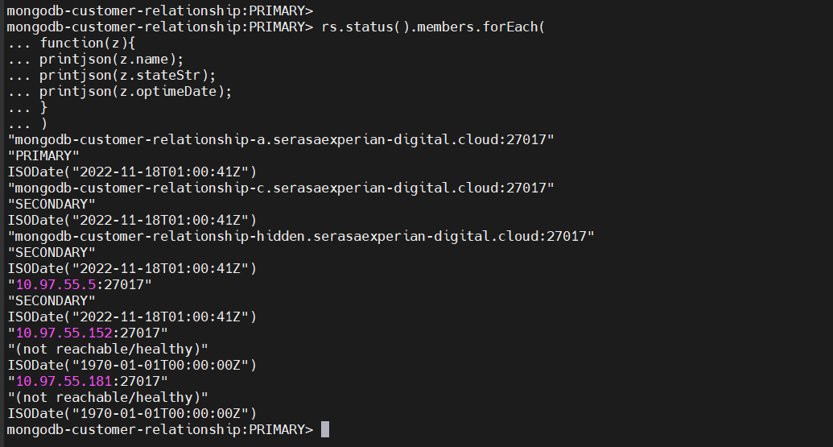
cfg = rs.conf()
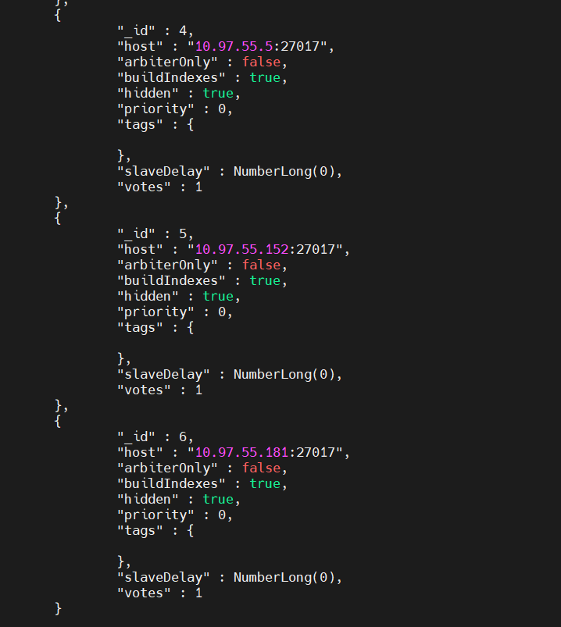
cfg.members[4].hidden = false
cfg.members[5].hidden = false
cfg.members[6].hidden = false
rs.reconfig(cfg)

